# Technical Memorandum/Internal Working Draft 1.01

# Subject: Population’s Exposures to Pollens in Different Climate Zones in United States

Version: Working Summary Version 1.02

From: Kun Mei

To: Dr. Panos G. Georgopoulos , YongZhang

Date: Nov 20, 2013

**1 Introduction**

Airborne allergenic pollen, which has been found to act synergistically with common air pollutants, such as ozone, will cause allergic airway disease (AAD). its distributions exhibit considerable variability in space and time. We can display both the temporal and spatial distributions based on either the mechanism models or statistical models using VERDI and Matlab. Then we use Monte-Carlo method to predict the exposure effect of the pollen in different areas.

**2 Methods**

**2.1 model**

**Data Collection**

Observed airborne pollen counts were obtained from six monitoring stations of the American Academy of Allergy Asthma and Immunology (AAAAI). The reported pollen data were classified only at the level of genus. Species under genus of either Betula or Quercus were not differentiated.

Data used here are from 1000 hour to 1200 hour, which is roughly considered as the flowering season, the spatial distribution of the 1000 hour and 1200 hour of scenario is displayed in figure 1 and 2,using VERDI. We are using logarithm instead of linear to make the figure more clear

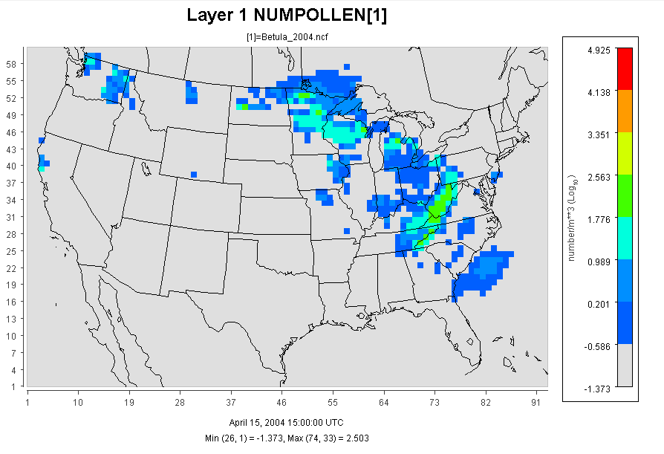

Figure 1 using VERDI

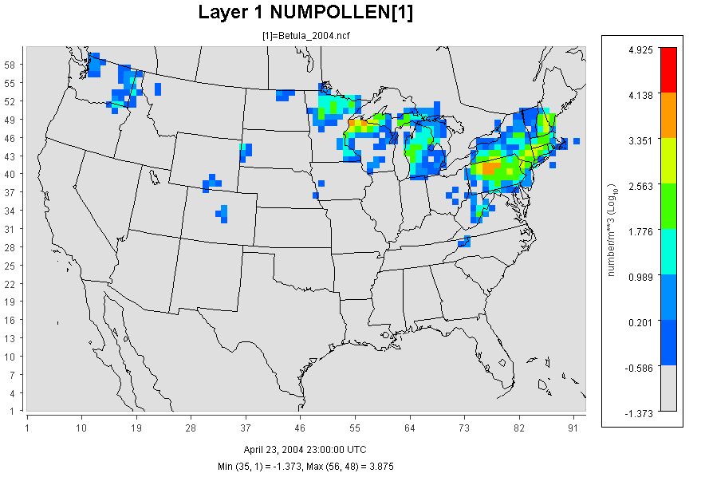

Figure 2 using VERDI

We used the time-average data to simulate the pollen distribution through the flowering season. The distribution is shown in figure 2.

Figure 2 using Matlab

**Exposure Method Selection**

**1 Inhalation**

Exposure can be quantified by multiplying the concentration of an agent times the duration of the contact. Exposure can be instantaneous when the contact between an agent and a target occurs at a single point in time and space .The summation of instantaneous exposures over the exposure duration is called the time-integrated exposure (Zartarian et al., 2007). Equation shows the time-integrated exposure.

*E= $\int{C(t)dt}$*

where: E = Time-integrated exposure (mass/volume),

t2– t1 = Exposure duration (ED) (time),

C = Exposure concentration as a function of time (mass/volume).

Dividing the time-integrated exposure by the exposure duration, results in the time-averaged exposure

In this paper, since the time step is 1 hour, we integrated the concentration through the whole flowering season (an average time about 200 hours),and we use numbers of pollen instead of the concentration which would be more reasonable in investigating the effect of pollen.

The Exposure Factors Data are from Exposure Factor Handbook 2011

The Population Data are from U.S Census Bureau: Age and Sex Composition:2010

**2 Dermal Exposure**

Dermal exposure to volatile chemical compound is fully studied already, however, the reports to the dermal exposure to pollen remains rare. We use dry deposition model to estimate the adherence of pollen to human skins.

The dry deposition model assumed that the transport of material to the surface is to be governed by three resistances in series: the aerodynamic resistance $r_{a}$

, the quasi-laminar layer resistance $r_{b}$, and the surface or canopy resistance $r_{c}$.The total resistance, $r_{t}$ by definition, the inverse of the deposition velocity

$v_{d}^{-1}=r_{a}+r_{b}+r_{c}$

For particle dry deposition, $v_{d}$ becomes

$v_{d}=v_{s}+\frac{1}{r_{a}+r_{b}+r_{a}*r_{b}*v_{s}}$

While $v_{s}$ is the particle settling velocity

$$r_{a}=\frac{1}{ku_{*}}\ln\left(\frac{z}{z_{0}}\right)$$

$$r_{b}=1/(u_{*}(Sc^{-\frac{2}{3}}+{10}^{-\frac{3}{St}})$$

$$v_{s}=\frac{ρ_{p}D_{p}^{2}gC_{c}}{18μ}$$

$$C_{c}=1+\frac{2λ}{D_{p}}\left(1.257+0.4e^{-\frac{0.55Dp}{λ}}\right)$$

Where $ρ_{p}$ is the density of the particle, $D_{p}$ is the particle diameter, g is the gravitational acceleration, μ is the viscosity of air, and $C_{c}$ is the slip correction factor.

$$Sc=\frac{μ}{ρ_{a}D}$$

$$St=\frac{v_{s}u_{*}^{2}ρ_{a}}{gμ}$$

$$D=\frac{k_{B}TC_{C}}{3πμD_{p}}$$

Where Sc is the Schmidt number, St is the Stokes number, and D is the molecular diffusivity,

So the direct deposition to the skin can be calculated now

1 indoor

$$M_{su}=A_{skin}v_{d} \int{C\left(t\right)dt}$$

2 outdoor

$$M_{su}=\frac{A_{skin}v_{d}λ_{v}}{λ_{v}+λ_{d}}\int{C\left(t\right)dt}$$

Where $M_{su}$ is the mass of the substance in the skin surface is, $A_{skin}$ is the exposed skin area.

The parameters $λ_{d}$ $λ_{v}$ are ventilation rate and indoor deposition velocity, respectively.

**3 Result and Discussion**

The exposure duration t can be set to different values for assessing exposure associated with different time durations. For example, it can be set to 1 hour to 24 hour to asses hourly to daily exposures.

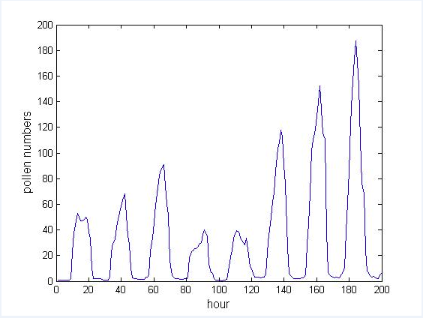

Figure time series of the pollen distribution froom 1000 hour to 1200 hour.

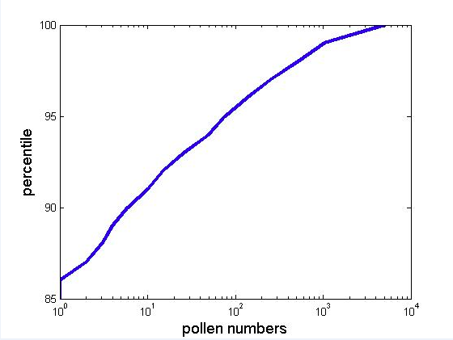

The exposure effect is shown as below

